PART A
(Part A: TO BE REFERRED BY STUDENTS)
Experiment No. 06
A.1 AIM:
To implement group by, having clause, aggregate functions for solving queries.
A.2 Pre requisite:
Fundamental knowledge of DML instructions and the SQL.
A.3 Outcome:
After successful completion of this experiment students will be able to

- Apply the DML commands on the developed relational models.
- Apply knowledge of relational algebra and structural query language to retrieve and manage data in relational databases.

A.4 Theory:
Aggregate Functions:
Aggregate functions are statistical functions such as count, min, max etc. They are used to compute a single value from a set of attribute values of a column:
count Counting Rows
Example: How many tuples are stored in the relation EMP?
select count(*) from EMP;
Example: How many different job titles are stored in the relation EMP?
select count(distinct JOB) from EMP;
max Maximum value for a column
min Minimum value for a column
Example: List the minimum and maximum salary.
select min(SAL), max(SAL) from EMP;
Example: Compute the difference between the minimum and maximum salary.
select max(SAL) - min(SAL) from EMP;
sum Computes the sum of values (only applicable to the data type number)
Example: Sum of all salaries of employees working in the department 30.
select sum(SAL) from EMP where DEPTNO = 30;
avg Computes average value for a column (only applicable to the data type number)
Note: avg, min and max ignore tuples that have a null value for the specified attribute, but count considers null values.
Grouping:
We have seen how aggregate functions can be used to compute a single value for a column. Often applications require grouping rows that have certain properties and then applying an aggregate function on one column for each group separately. For this, SQL provides the clause group by <group column(s)>. This clause appears after the where clause and must refer to columns of tables listed in the from clause.

Syntax:
select <column(s)> from <table(s)> where <condition> group by <group column(s)> [having <group condition(s)>];

Those rows retrieved by the selected clause that have the same value(s) for <group column(s)> are grouped. Aggregations specified in the select clause are then applied to each group separately. It is important that only those columns that appear in the <group column(s)> clause can be listed without an aggregate function in the select clause!
Example: For each department, we want to retrieve the minimum and maximum salary.
select DEPTNO, min(SAL), max(SAL) from EMP group by DEPTNO;

Rows from the table EMP are grouped such that all rows in a group have the same department number. The aggregate functions are then applied to each such group. We thus get the following query result:
DEPTNO | MIN(SAL) | MAX(SAL)
10 | 1300 | 5000
20 | 800 | 3000
30 | 950 | 2850
Rows to form a group can be restricted in the where clause. For example, if we add the condition where JOB = ’CLERK’, only respective rows build a group. The query then would retrieve the minimum and maximum salary of all clerks for each department. Note that is not allowed to specify any other column than DEPTNO without an aggregate function in the select clause since this is the only column listed in the group by clause (is it also easy to see that other columns would not make any sense).
Once groups have been formed, certain groups can be eliminated based on their properties, e.g., if a group contains less than three rows. This type of condition is specified using the having clause. As for the select clause also in a having clause only <group column(s)> and aggregations can be used.
Example: Retrieve the minimum and maximum salary of clerks for each department having more than three clerks.
select DEPTNO, min(SAL), max(SAL) from EMP where JOB = ’CLERK’ group by DEPTNO having count(job) > 3;
A query containing a group by clause is processed in the following way:
- Select all rows that satisfy the condition specified in the where clause.
- From these rows form groups according to the group by clause.
- Discard all groups that do not satisfy the condition in the having clause.
- Apply aggregate functions to each group.
- Retrieve values for the columns and aggregations listed in the select clause.

  - Task: For given tables solve below queries:
category_header
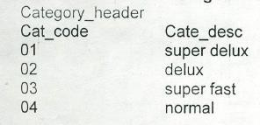
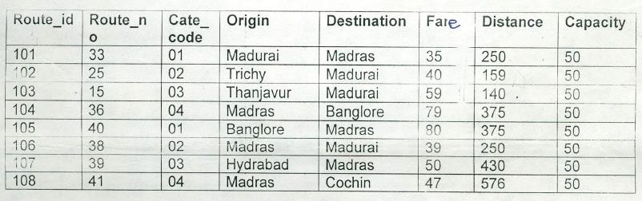
route_Header

Place Header:
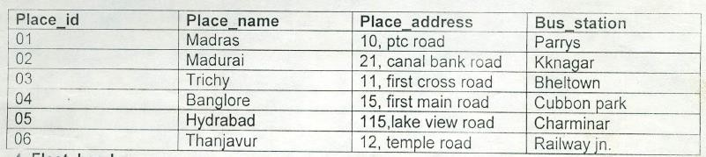
Fleet Header:
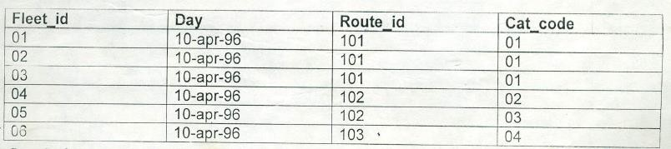
Ticket Header:
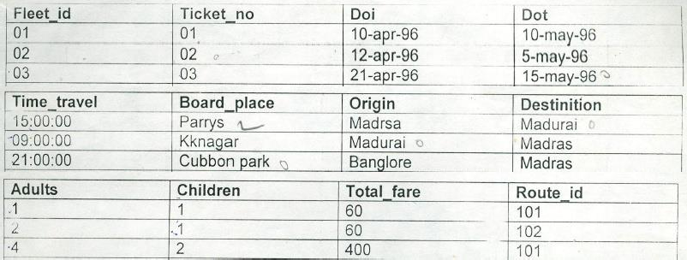

Ticket Detail:
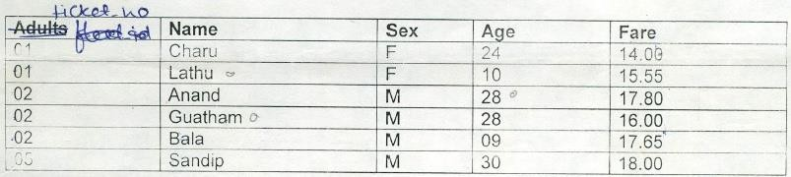
Route Detail:
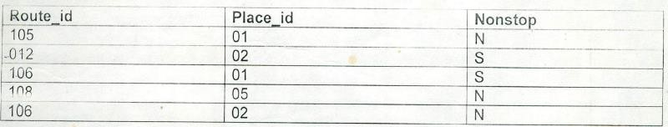
Queries:
- Give average of the total fare.
- Give the total collection of fare.
- Which bus runs for minimum distance?
- Give the total number of people who have traveled so far group by ticket number.
  - Find out total fare for routes with same origin.
  - Find out total fare for routes with origin as madras.
  - Calculate average fare for each ticket.
  - Find out details of fleets that run on route number 33 or 25.
  - Count how many male or female passengers have travelled till now.
  - Count total number of routes for each category except category 02.

PART B
(PART B: TO BE COMPLETED BY STUDENTS)
Roll No: C172 | Name: Parva Gaglani
Class: D | Batch: D2
Date of Experiment: 29/3/26 | Date/Time of Submission: 29/3/26
Grade :

B.1 Tasks given in PART A to be completed here
1. Give average of the total fare.
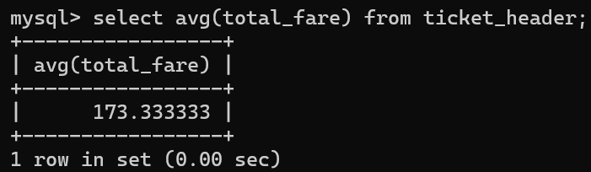
2. Give the total collection of fare.
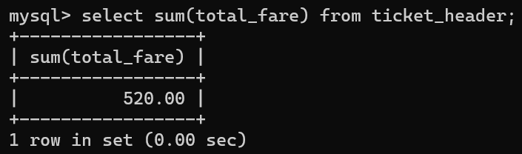

3. Which bus runs for minimum distance?
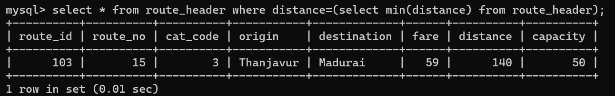
4. Give the total number of people who have traveled so far group by ticket number.
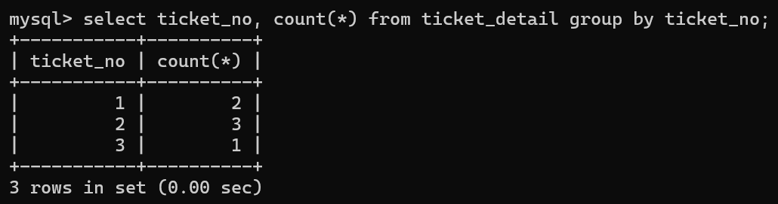
5. Find out total fare for routes with same origin.
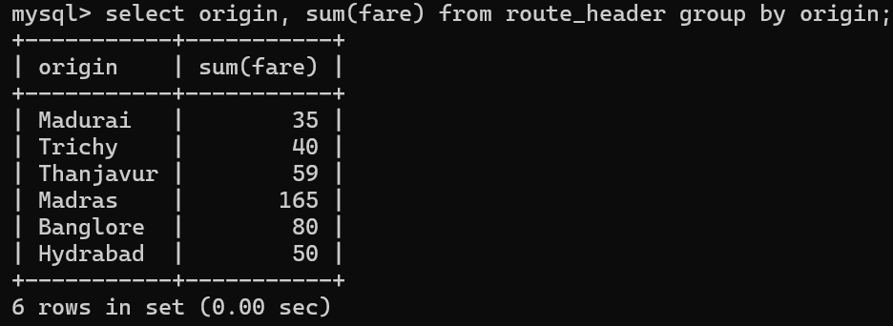

6. Find out total fare for routes with origin as madras.
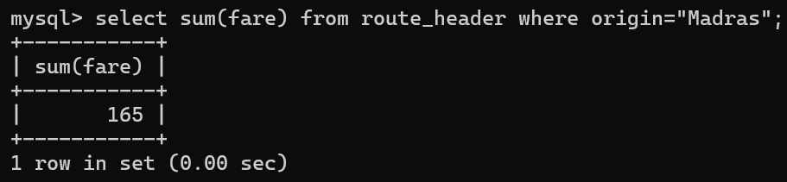
7. Calculate average fare for each ticket.
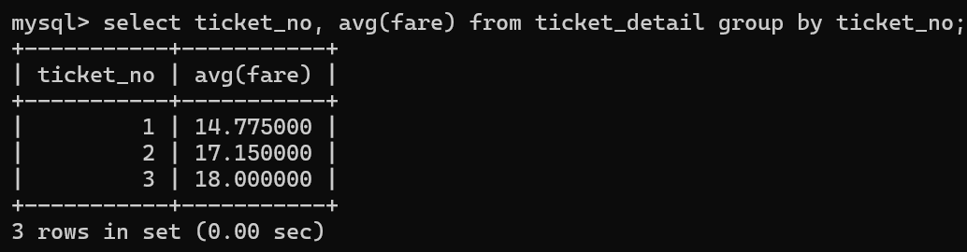
8. Find out details of fleets that run on route number 33 or 25.
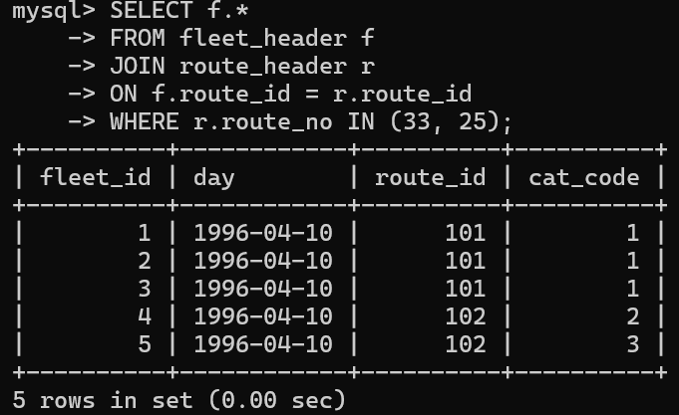
9. Count how many male or female passengers have travelled till now.
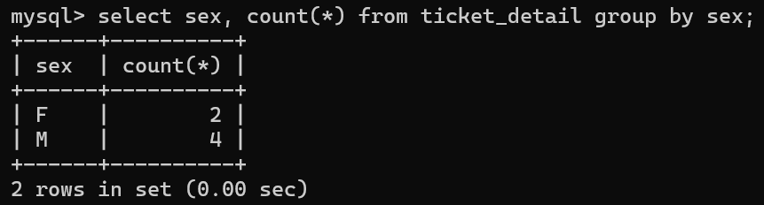
10. Count total number of routes for each category except category 02.
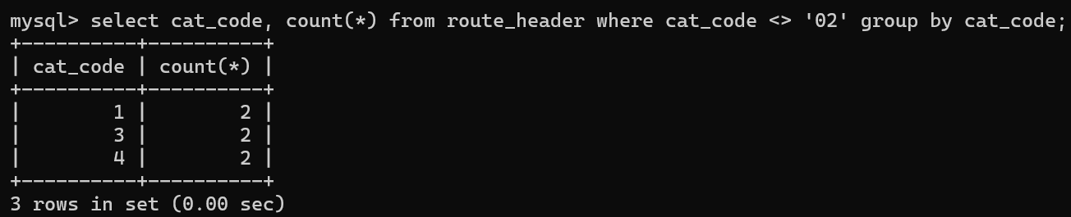
B.2 Conclusion:
In this experiment, we successfully implemented SQL concepts such as GROUP BY, HAVING clause, and aggregate functions to solve a variety of database queries.
B.3 Question of Curiosity
- Solve below queries for given tables:

Distributor (Dno, Dname, Daddress, Dphone)
Item (Itemno, Itemname, Colour, Weight) Dist_Item (Dno, Itemno, Qty)

- Count total number of items of each color.
Select colour, count(itemno) from item group by colour;
- Count number of items supplied by each distributor.
Select dno, count(itemno) from dist_item group by dno;

